To set up jenkins we need

**1. AWS-UBUNTU INSTANCE**

**2. DOCKER ON UBUNTU OS**

**3. JDK**

**4. MAVEN**

**5. JENKINS**

**Step:1 AWS UBUNTU INSTANCE + Connect using Moba x-term**

Step:2 Docker installation

link: https://docs.docker.com/engine/install/ubuntu/

> sudo apt-get update

> sudo apt-get install ca-certificates curl gnupg lsb-release

> curl -fsSL https://download.docker.com/linux/ubuntu/gpg | sudo gpg --dearmor -o /usr/share/keyrings/docker-archive-keyring.gpg

> echo "deb [arch=$(dpkg --print-architecture) signed-by=/usr/share/keyrings/docker-archive-keyring.gpg] https://download.docker.com/linux/ubuntu $(lsb_release -cs) stable" | sudo tee /etc/apt/sources.list.d/docker.list > /dev/null

> sudo apt-get update

> sudo apt-get install docker-ce docker-ce-cli containerd.io docker-compose-plugin

----------to verify docker installation

> sudo docker -v

STEP:3 INSTALL JDK

sudo apt-get update

Sudo apt install default-jdk -y

To check the java version

>Java --version

STEP: 4 INSTALL MAVEN

**sudo apt install maven -y**

Step:5 Install Jenkins

curl -fsSL https://pkg.jenkins.io/debian-stable/jenkins.io.key | sudo tee /usr/share/keyrings/jenkins-keyring.asc > /dev/null

echo deb [signed-by=/usr/share/keyrings/jenkins-keyring.asc] https://pkg.jenkins.io/debian-stable binary/ | sudo tee /etc/apt/sources.list.d/jenkins.list > /dev/null

sudo apt-get update

sudo apt-get install jenkins

To start Jenkins Service

sudo service jenkins start

sudo service jenkins status

goto> aws>ec2instance>copy the ipaddress:8080 in browser to begin with Jenkins configuration

goto to the browser and enter: ipaddress:8080

to get secret password

sudo cat /var/lib/jenkins/secrets/initialAdminPassword

sudo chmod 777 /var/run/docker.sock

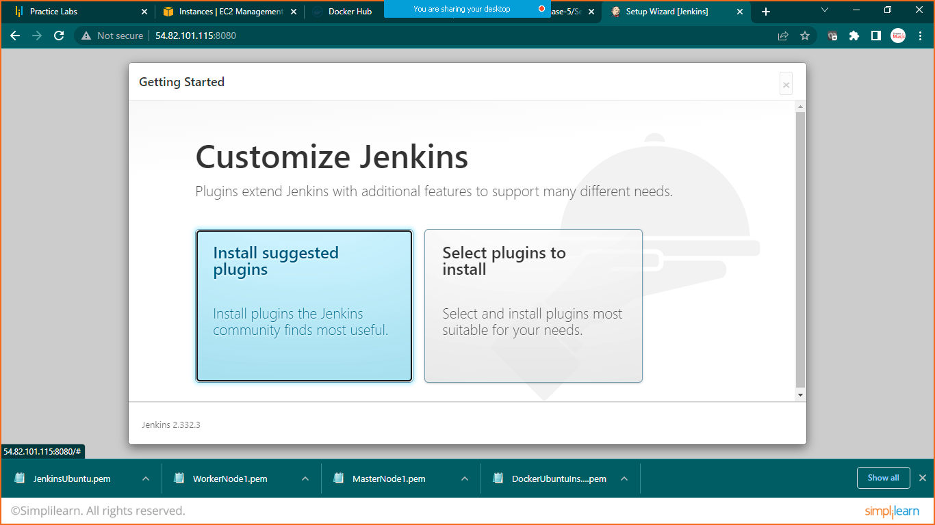

Click on install suggested plugins

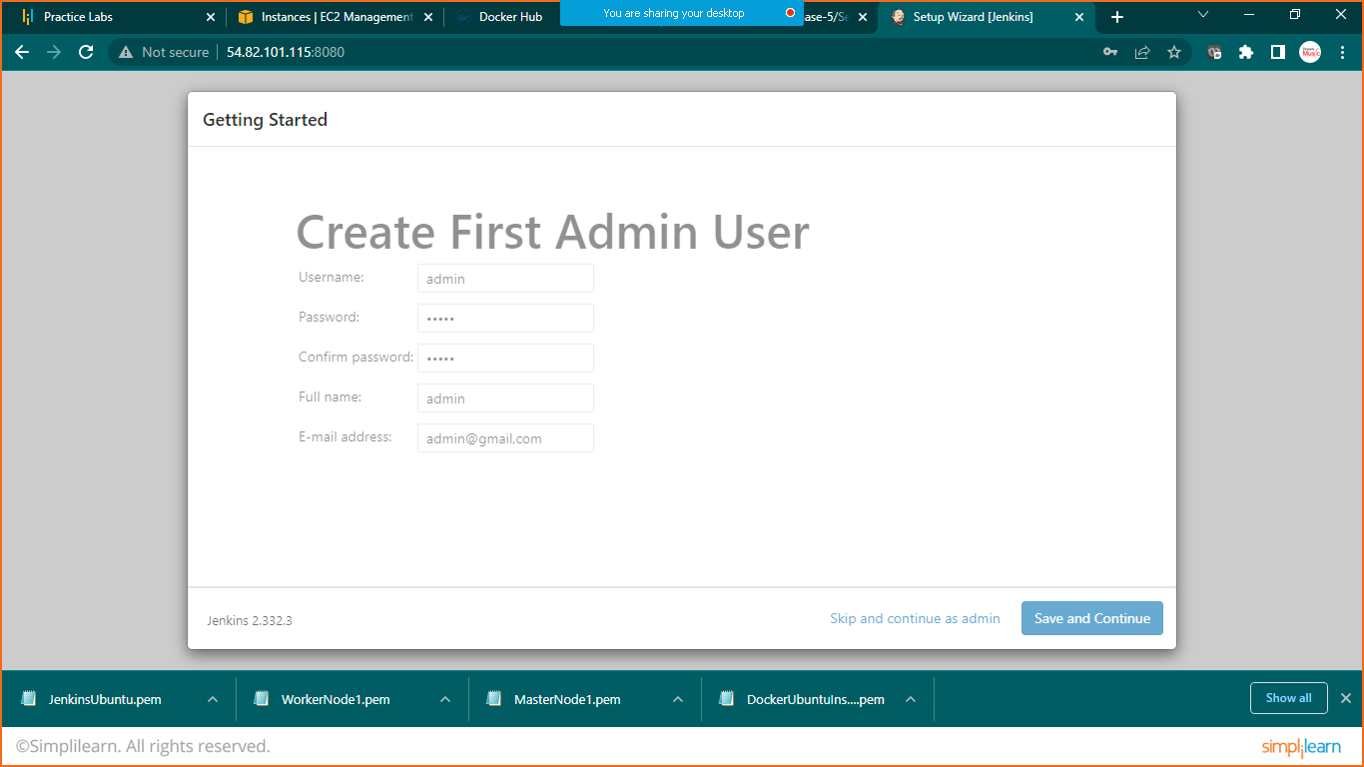

Add details and click on save and continue

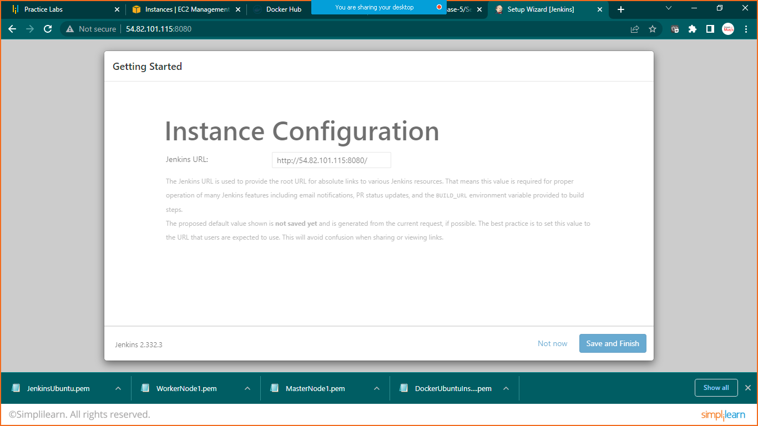

Click on save and finish

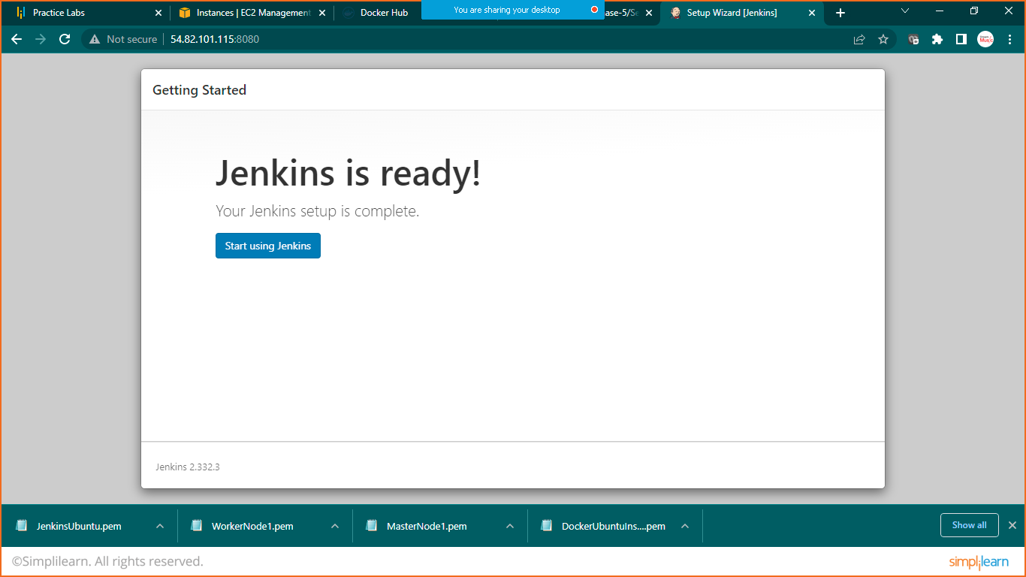

Start using Jenkins

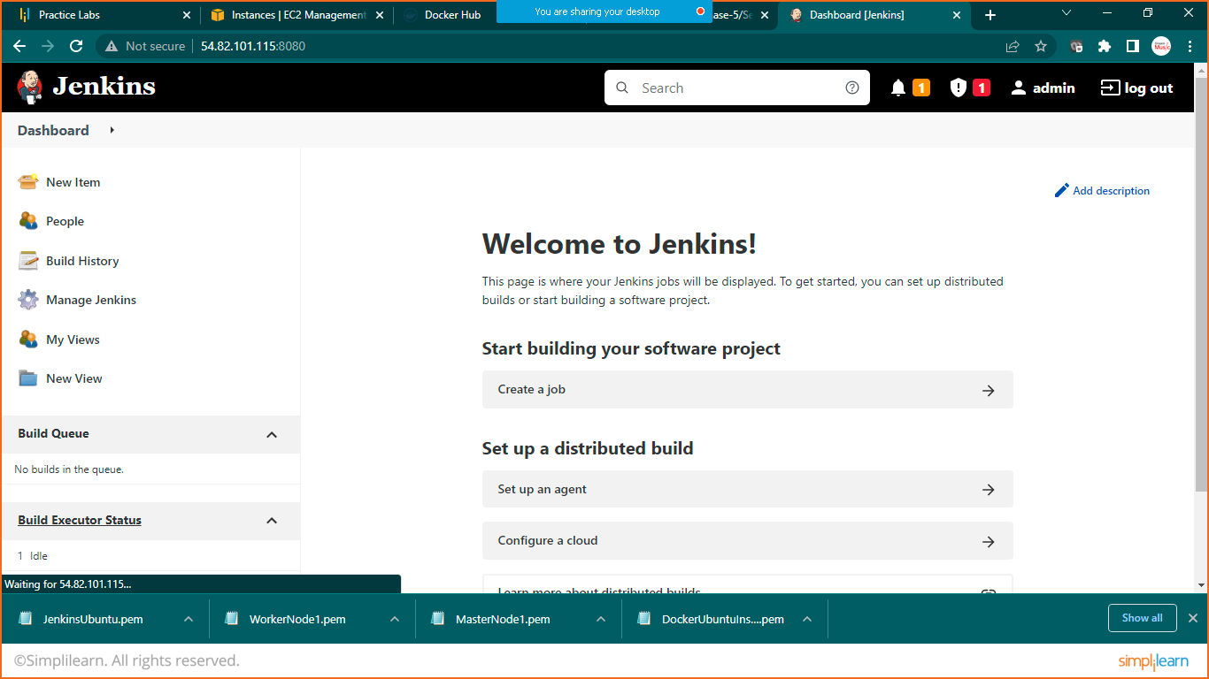

Click on create job and select freestyle project

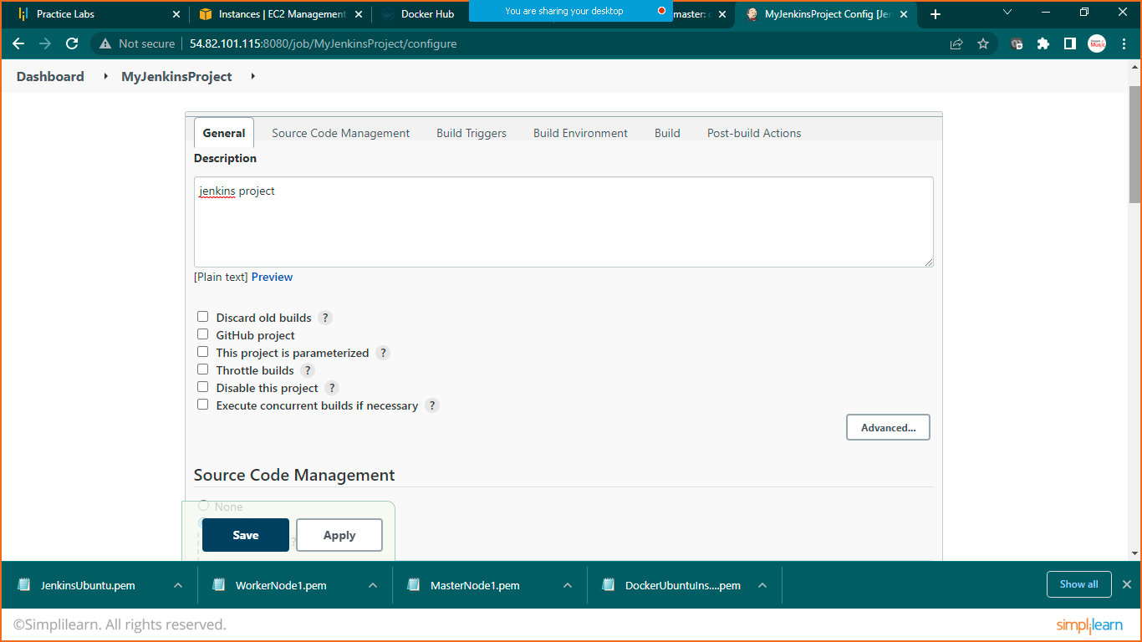

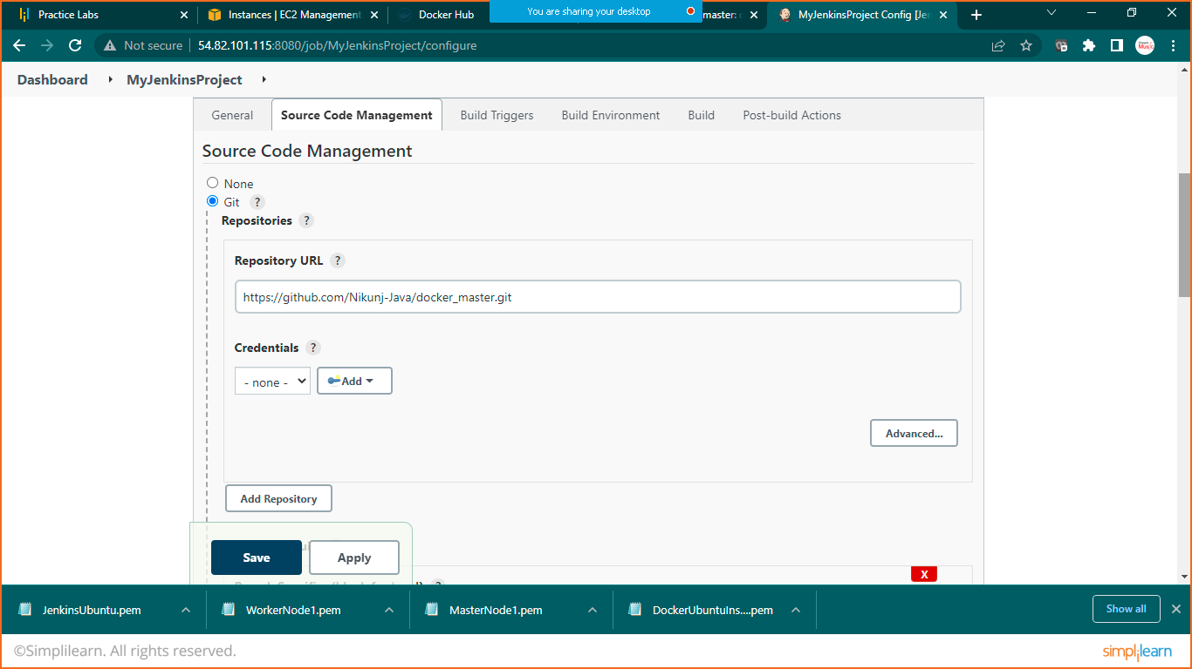

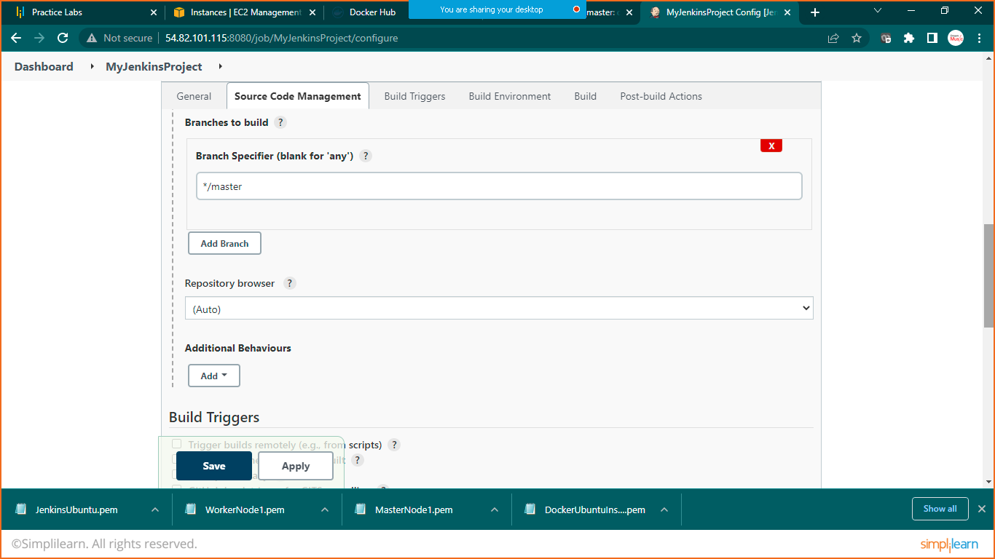

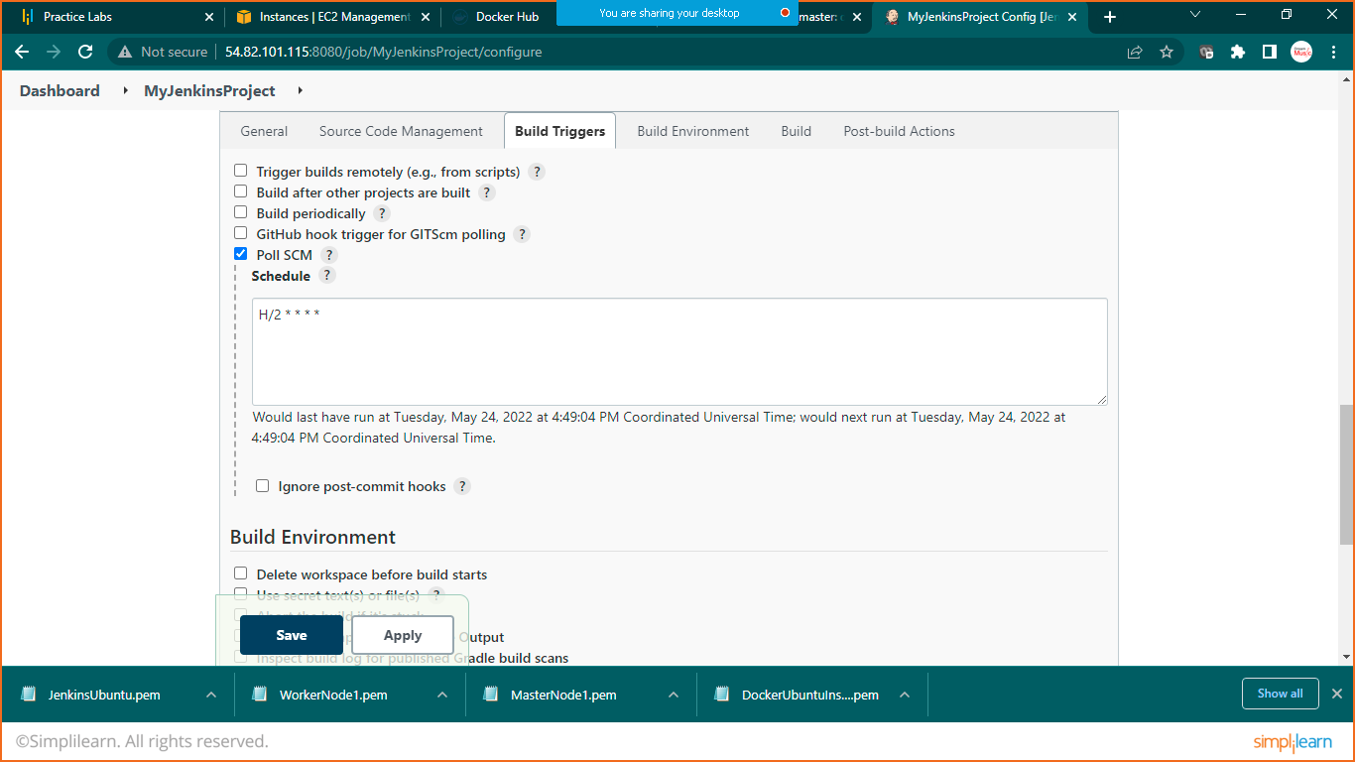

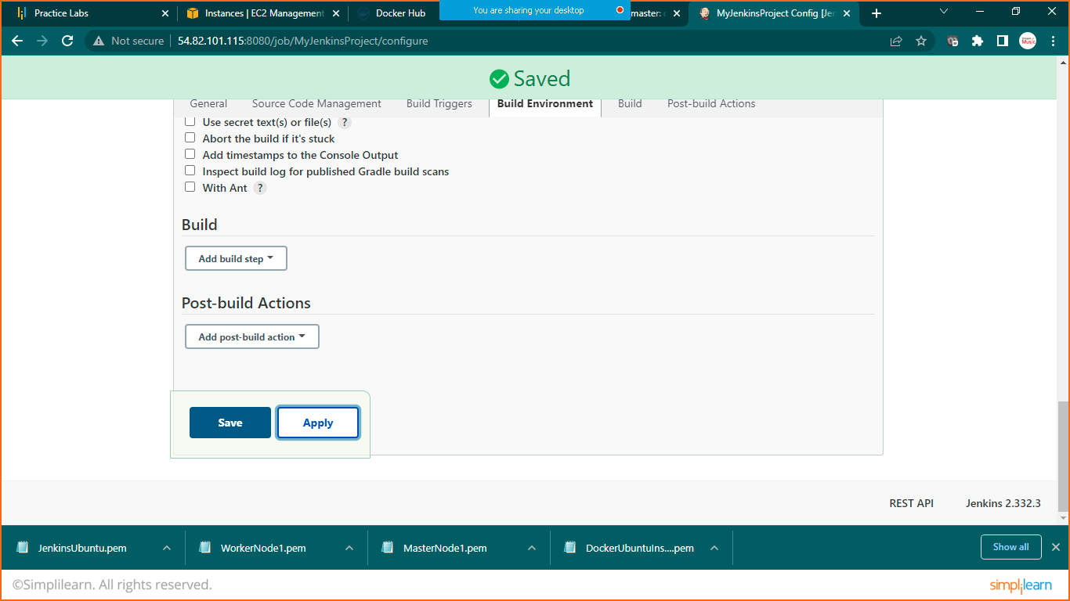

PART:2 PIPELINE PROJECT (CI/CD)

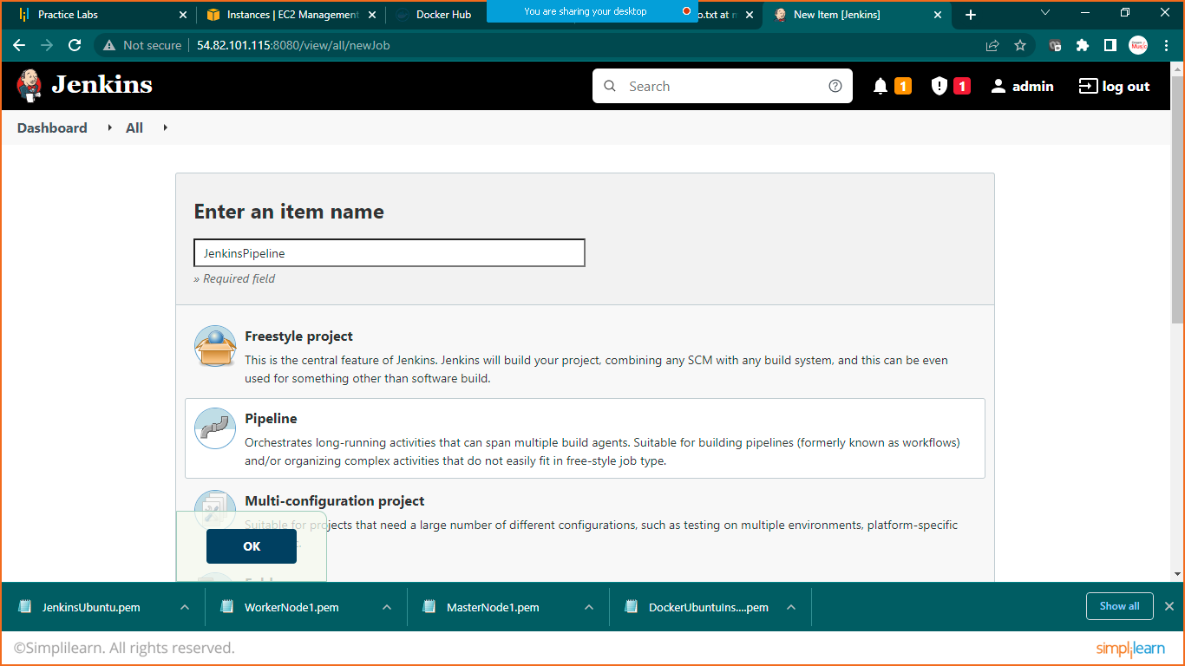

Select pipeline project

Link: https://github.com/Nikunj-Java/SpringBootDockerApp.git

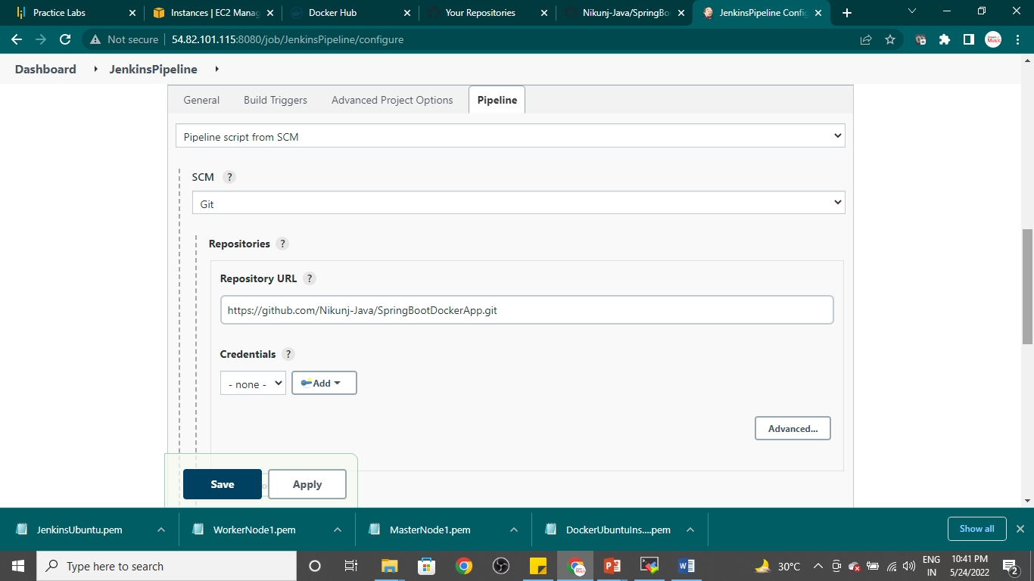

Save it click on build now

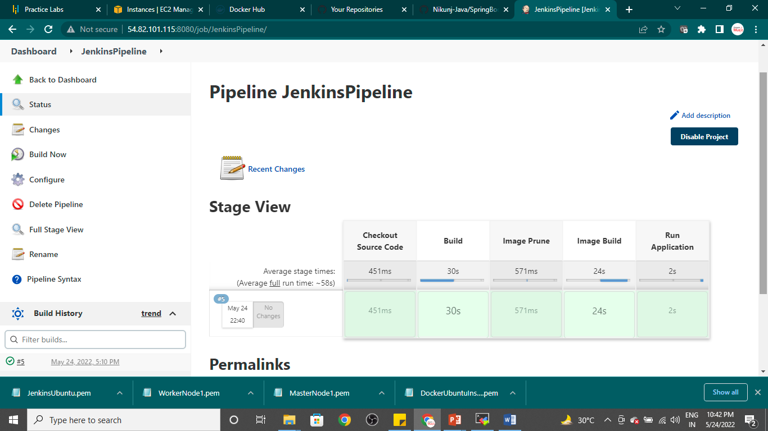

Goto moba xterm and run below code

Sudo docker images

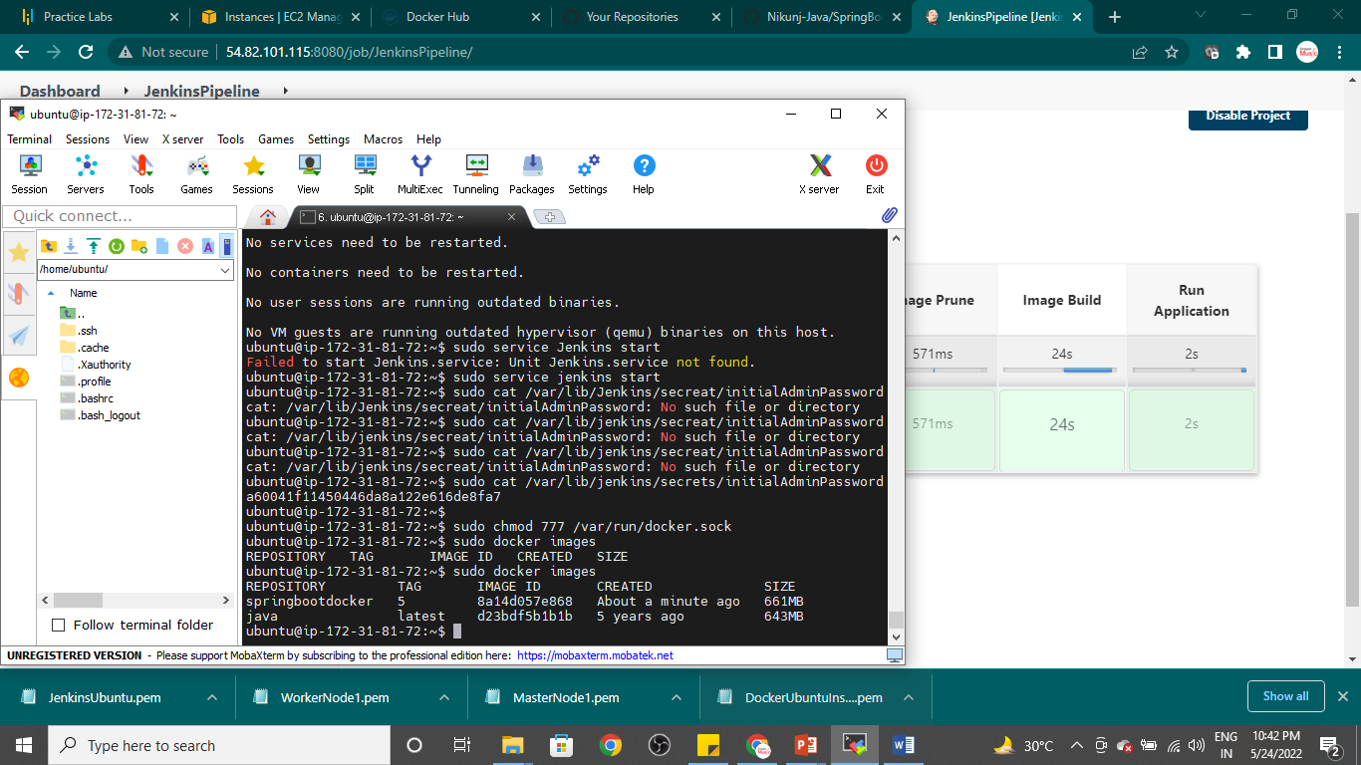

You will see that **springbootdocker** is running